Movie ratings vs Return on Investment
When companies make movies, they want to know that they can make a profit. The goal of this project is to take movie parameters such as ratings, genres, release date, and budget to predict if a movie will be successful.
- Data
The data was taken from Kaggle and includes 507 movies. The columns are Title, MPAA Rating, Budget, Gross, Release Date, Genre, Runtime, Rating, Rating Count, and Summary.
- Data Cleaning
The original data had 7545 entries. Most rows were removed from the original data. Those rows contained null values or were actors and not movies. Also, two movies were removed because they had no Rating or Rating count. A duplicate entry for Jurassic Park III was averaged.
The data was looked at graphically to see if there were any outliers or other abnormalities. There are two, Titanic and Avatar, but we know those values are accurate.
There are 4 MPAA rating levels, and 16 genres. Also, all currencies appear to be in USD.
- EDA
An ROI column was created by dividing Net Profit by the Budget.
The genre categories were not evenly distributed which would cause the model to be skewed. A genre frequency column was created to help standardize the genre counts.
The Net profit was analyzed to look for negative values. None of the movies were flops. I think we can assume that this data set only includes blockbuster successes. This means future models using this data assume the movie will succeed.
Avatar and Titanic were removed from the data set because they are outliers based on net profit.
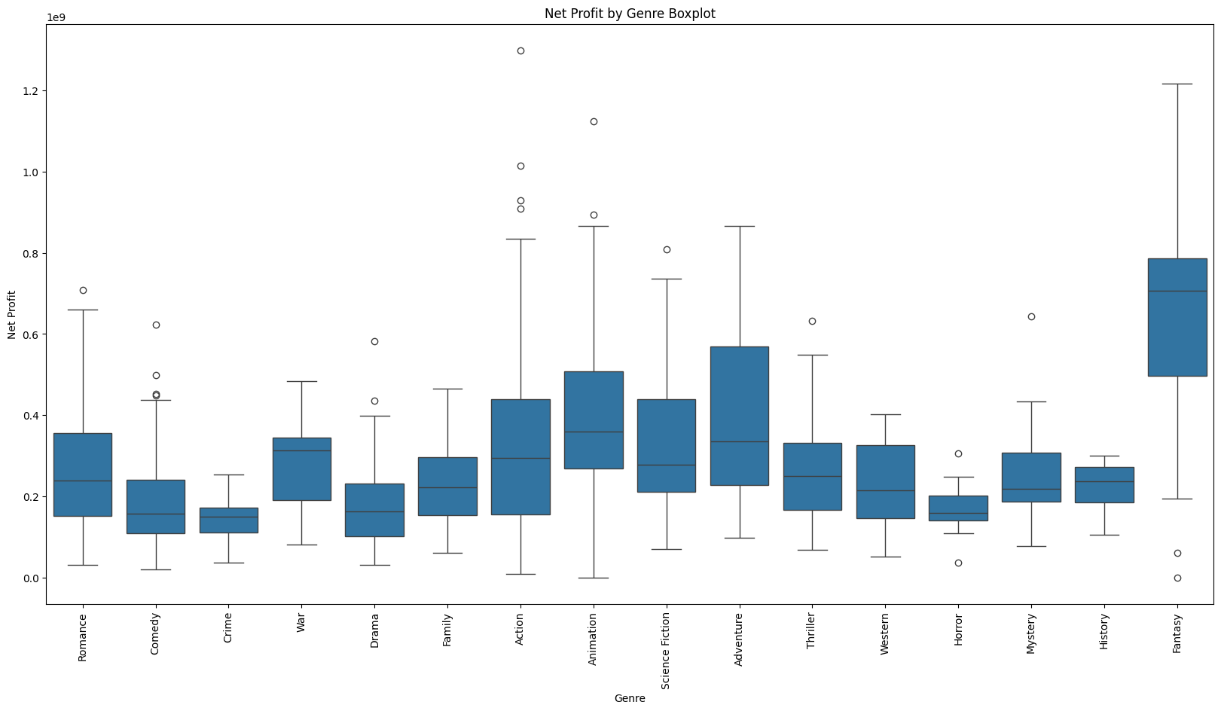
This box plot shows the movies’ net profit grouped by genre. It is important to look at the outliers because those are the best movies. Also, the data shows Fantasy movies on average yield the most profit.
Looking at ROI, The Blair Witch Project had to be removed as an outlier because it’s ROI was 4000. The next highest ROI was My Big Fat Greek Wedding at around 75. This shows that even if you have a low budget, you can still earn a lot of money. However, most movies ROIs’ are less than 13.
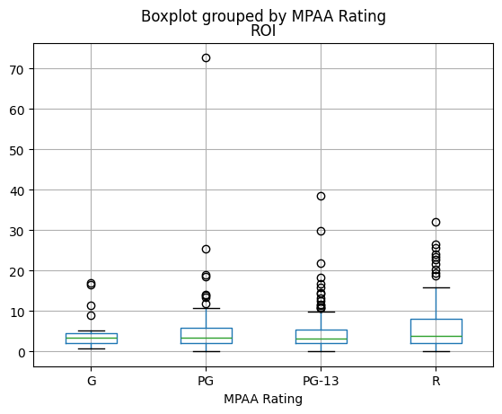
This Box plot shows movies grouped by MPAA rating and ROI. PG-13 and R movies have the best chance to be outliers. However, most movies’ profits correspond to their budgets. This is shown by the ROI ranges being very similar across MPAA ratings.
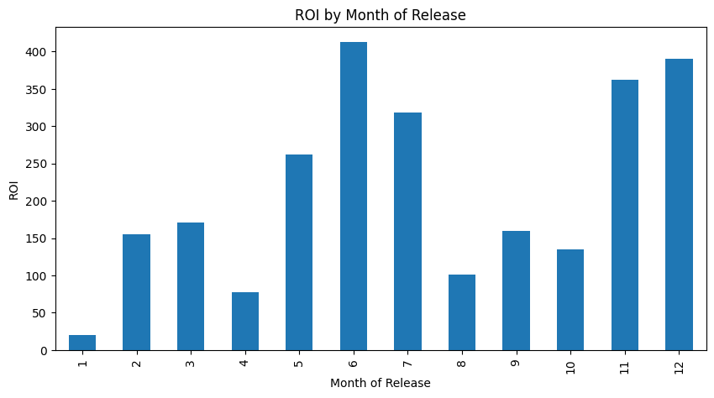
This Bar Graph shows movies ROI grouped by release month. You can see that the most successful movies are released in the summer and fall.
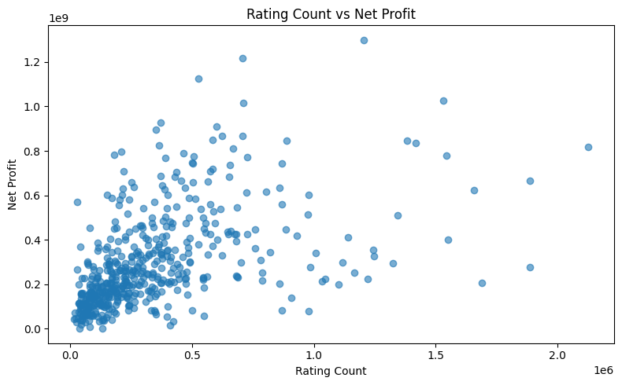
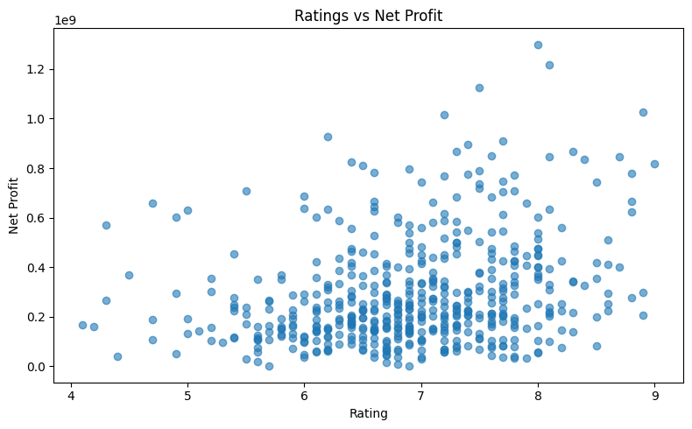

The data also shows that higher viewer ratings and rating counts correspond to a higher Net profit.
- Modeling
The data was scaled and dummy variables were created for MPAA rating, and Genre categories. The summary and title columns were also removed from the data. Then the data was split into training and test sets.
Random Forest, XGBoost, Linear Regression, and SVR were tested as potential models.
The following tables show the model metrics and parameters.

Model | training_R^2 | testing_R^2 | MAE
RF Gross, ROI, Net | 0.9241 | 0.4595 | 70442718.35
RF Gross | 0.9402 | 0.577 | 109427513.7
RF ROI | 0.9286 | 0.5161 | 2.4465
RF Net Profit | 0.9252 | 0.4922 | 101617691.7
XGBoost Gross | 0.6336 | 0.5799 | 107739359.1
Linear Regression Gross | 0.6345 | 0.6052 | 106232011.6
SVR Gross | -0.0825 | -0.0722 | 165470378.2

There were three predictive features to choose from: ROI, Gross, and Net Profit. Gross Preformed best overall with testing data. Ergo gross was used as the predictive value.
Linear Regression out preformed Random Forest, XGBoost and SVR. Linear Regression was chosen for the final model. It also has less variability by about 1 million dollars.
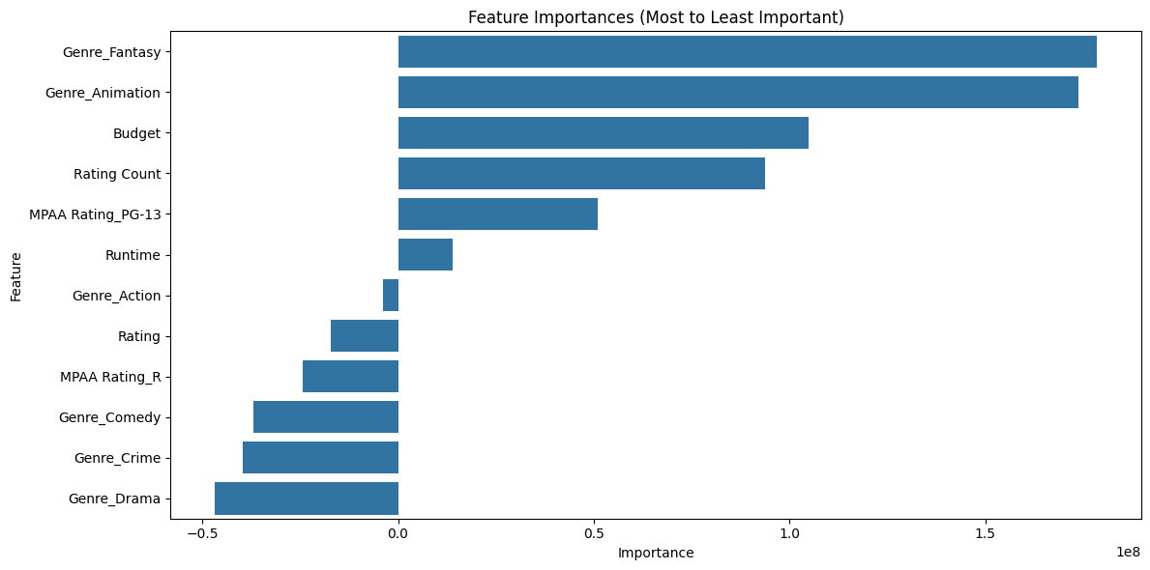
The bar graph above shows Feature importance based on the grid search best k features. Budget, Rating Count, Runtime and Rating are in the top features. The other features are the MPAA Rating and Genres. The MPAA Rating and Genres should be kept as whole categories because they are dummy variables. Ergo, no features were dropped from the final model other than the prediction variables ROI and Net Profit.
- Discussion
This data set is of Hollywood blockbusters. It shows that successful movies have more critic reviews, higher ratings, and higher budgets. Movies released in the fall or summer also have a better chance of being more successful.
This data has no movie flops which makes it extremely biased. The model will most likely not report a movie as a flop and if it did, there is no model data to support that hypothesis.
The final model created with this data had a R squared value of .63 which shows there is correlation between features, but it’s not the best. Also, the MAE for the model was 106 million. That is a very large number if you are making a very small budget movie.
I think the most helpful information in this project is found in the data analysis, not the modeling. The general correlation between release month, ratings and genre potentials are the most important thing when looking at how successful a movie could be.

Future discussion

